Turn Radius Report 2.0

F22

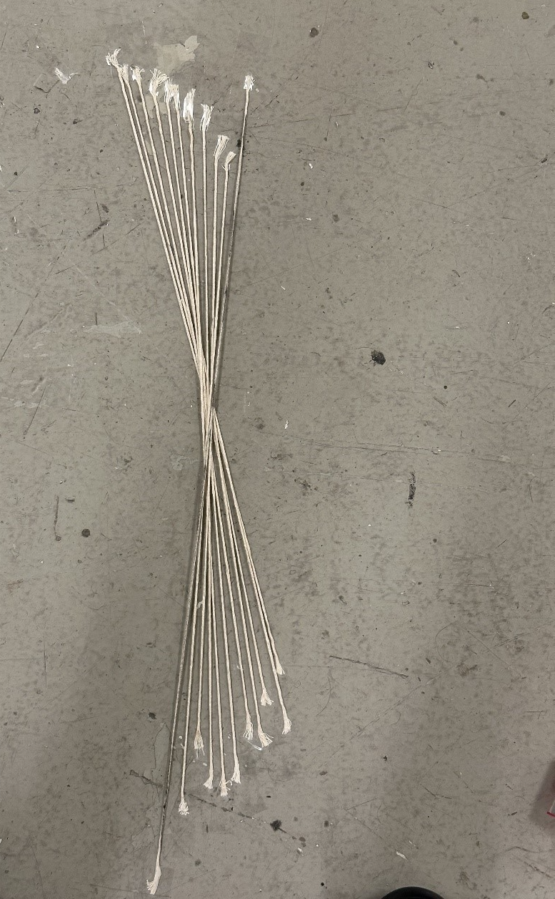

02/25/2025

**Steering Wheel vs Wheel Angle Test**

The circumference of F22s steering wheel was marked every 10-degrees. The 0-reference mark and pointer were aligned at the top of the steering wheel while the wheels were aligned straight ahead. This is shown in Fig. 1 below. Next, the steering wheel was turned from its centered position at 10-degree intervals until full lock was achieved. Considering this approach the upscale, a downscale measurement was also performed similarly from full lock back to the centered position.

These measurements were taken at each of the front wheels. However, this was performed only in the direction of turning that would cause the measured wheel to be the outside wheel of a turn. This gives us plots of the steering wheel angle vs wheel angle for either front tire, if it's the tire on the outside of the turn.

**Figure 1. Steering Wheel with Indicator and Degree Lines**

For the wheel, a large straight metal plate was placed on the side of the left wheel as seen in Figure 2. A string of yarn was placed against the plate and was taped down to the floor. With the car wheels facing forward, the first piece of string represented a 0-degree wheel angle. Next, the driver turns the steering wheel to the left with one tick mark correlating to 10-degree steering angle. The metal plate is then picked up and placed to line up against the now-turned wheel. The string is aligned to the metal plate and tapped down. The process of turning the wheel, placing the metal sheet to serve as a straight edge for the string which will eventually measure the wheel angle. A complete representation of the array of springs are seen in Figure 3 This is repeated until the left wheel is turned fully to the right until it locks.

Once the lock had been reached a high-quality photo was taken to measure the many strings of yarn using the Digital Image Correlation method (DIC); which will be used to measure the wheel angle. After the picture is taken remove the tape and strings to conclude the upscaling measurements. Ultimately this will show the correlation between the steering angle from the steering wheel to the wheel angle from the strings on the ground. Now to begin the downscaling process the wheel is turned back to its initial position, but while placing the metal plate and taping string at each increment.  Once this is complete, take the photo that will be used for DIC for downscaling. Now repeat this same process for the right wheel making a left turn for both upscale and downscale.

**Figure 2. Metal Plate Alignment**

**Figure 3. Wheel Angle String Placement**

The plots displayed below is the data regarding the relationship between steering angle and wheel angle dependent on the turn. Figure 4 depicts a left turn and its corresponding inner and outer wheel measurements; while Figure 5 shows a right turn. It was noted that during the test, the left turn locked at 95 degrees, and during the right turn locked at 105 degrees. The possible reason for this discrepancy is that the steering rack wasn’t centered prior to the experiment. Both Figures 4&5 represent the averages of upscale and downscale data thus reducing possible error

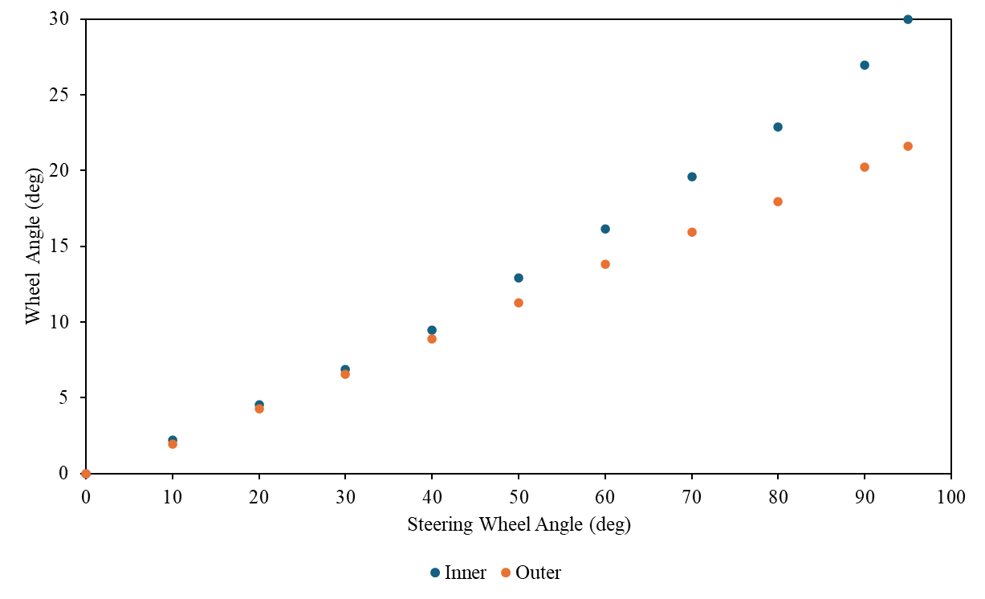

**Figure 4. Left turn Inside vs outside Wheel**

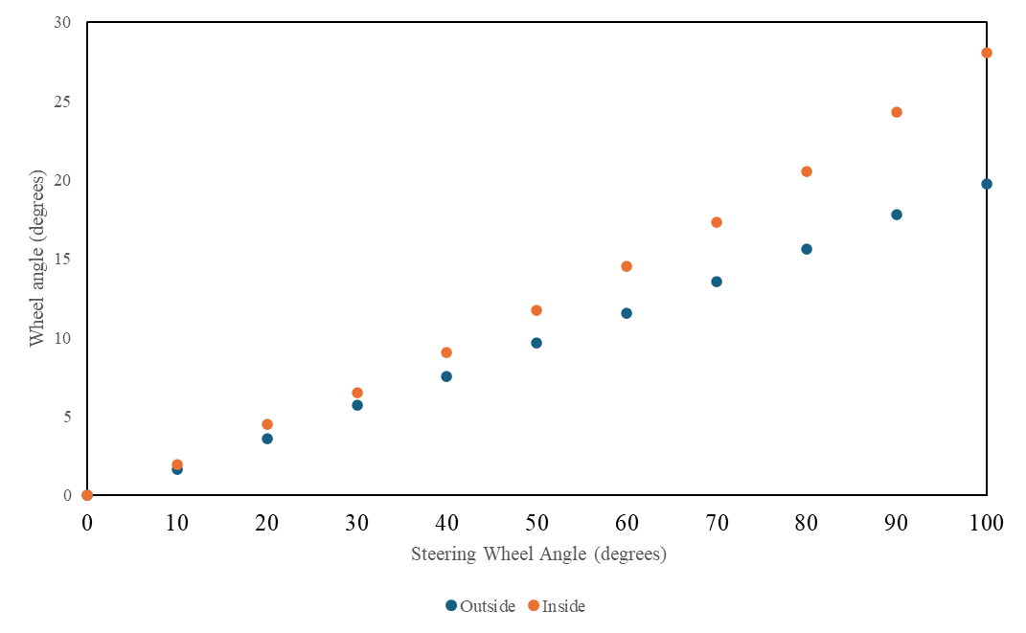

**Figure 5. Right turn Inside vs outside Wheel**

**Turn Radius Calculation**

To calculate the turn radius, we needed a few measurements from the car such as the Wheelbase (WB) and the Front Track Width (TF). The following equation is used to calculate the turn radius of the outer wheel given the wheel angle δ0*𝛿0*. We took measurements of the steering angle and the wheel angles on the way from 0 to 100 degrees and from 100 degrees back down to 0. We did these upscale and downscale measurements on both turning directions to help negate the error. An average was calculated for the wheel angle based on the average of the upscale and downscale measurements of both the left and right wheel.

(1)

In Eq. (1) is the equation we used to calculate the turn radius, and the wheel angle δ0*𝛿0*  is associated with a steering wheel angle input. With the above equation and the wheel angle measurements taken from the car we can calculate the range of the turn radius for both left and right. The Wheelbase for F16 is 66” along with the Front Track Width being 49.5” and Eq. (1) accounts for the values being in inches and converts the output to feet.

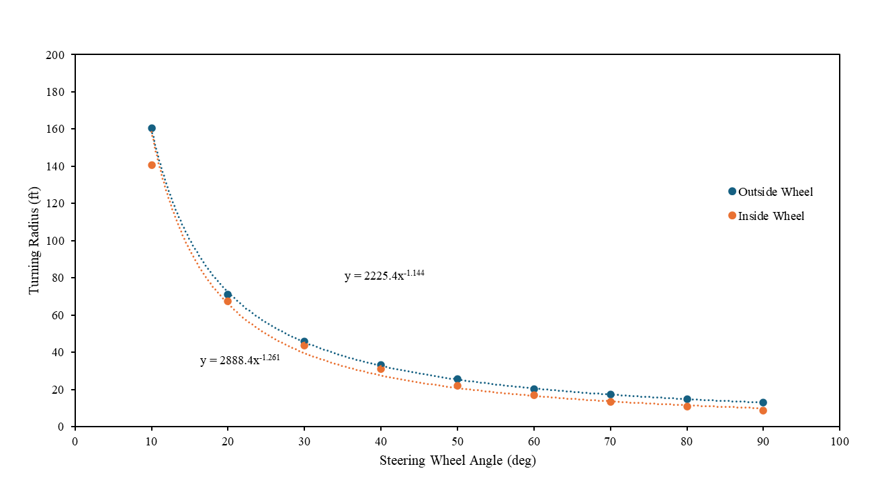

**Figure 6. Turn Radius Going Left**

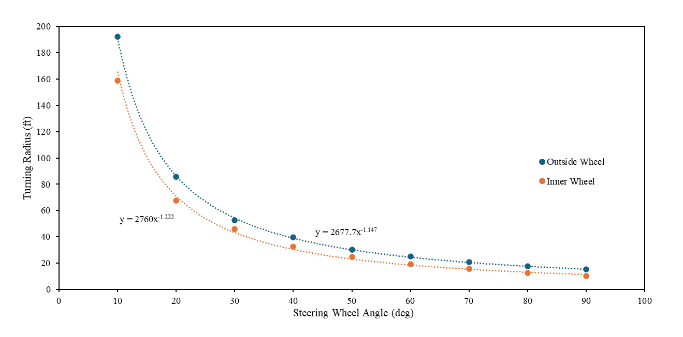

**Figure 7. Turn Radius Going Right**

The plots above show the steering angle and the turn radius at that steering angle, it was calculated using the wheel angle which was measured above. Figure 6 shows the inner and outside wheel steering angle vs turn radius for a left turn. Figure. 7 shows the inner and outsider wheel steering angle vs turn radius for a right turn.

**Results/Conclusions**

The F22 test was performed because the previous F16 test data had substantial amounts of play in the steering system. It was noted that around 5 to 10 degrees of steering wheel rotation. It was observed that the 22 vehicle had less translational and rotational play than its 16 counterpart, but the degree difference for the F22 to reach full lock was approximately 10 degrees. This probably stems from the steering rack not being centered before measurements were taken. Ultimately the turn radius data effectively shows real experimental data of steering wheel angle vs turn radius that is in line with theoretical concepts.